atxtcustom Arbortext Package Creation and Deployment - RH1
Schindler CRD Applications

Exported on 2025-08-19 05:06:58

Table of Contents

1 atxtcustom Arbortext Package Creation 3
2 Source File Preparation 4
3 Compile Source Files 6
4 Deployment on APE Server 8
5 wvs.jar creation and windchill OOTB jars 9
6 Issues and Resolution 13
6.1 APE worker is not starting form Worker Agent Administration 13
6.1.1 Issue 13
6.1.2 Resolution 13

atxtcustom Arbortext Package Creation
- atxtcustom Arbortext Package Creation atxtcustom Arbortext Package Creation Source File Preparation Compile Source Files Deployment on APE Server wvs.jar creation and windchill OOTB jars Issues and Resolution APE worker is not starting form Worker Agent Administration Issue Resolution
- Source File Preparation
- Compile Source Files
- Deployment on APE Server
- wvs.jar creation and windchill OOTB jars
- Issues and Resolution
  - APE worker is not starting form Worker Agent Administration
    - Issue
    - Resolution

Source File Preparation
- Copy ext folder from edm-windchill-master\atxtcustom\src to eclipse
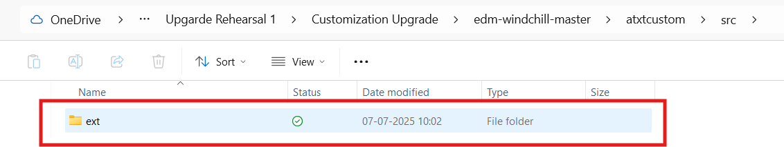
- All deprecated APIs are fixed as per Windchill 13.0.2.5. Refer WC_13_0_2_5_Code_Upgrade.xlsx sheet API details
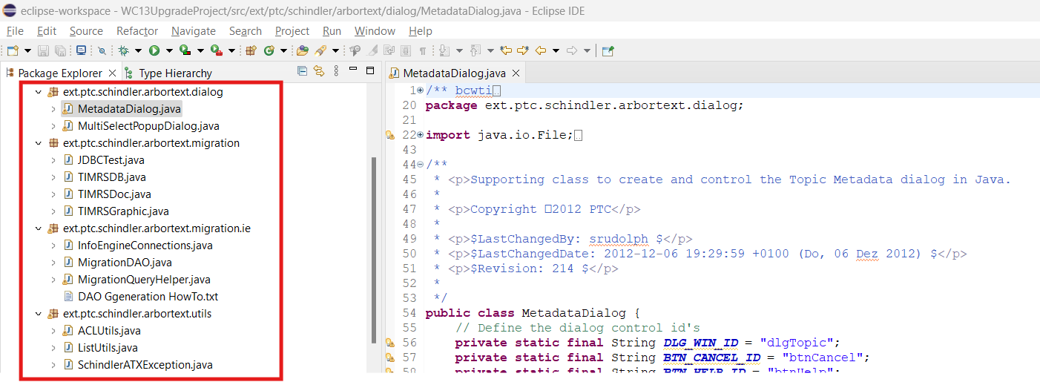
- Created C:\SCH\sourceFile folder structure and added ext package
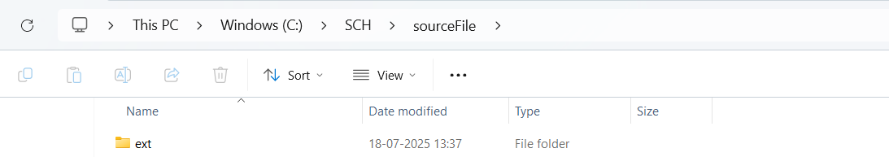
- Copy Below jars to C:\SCH\sourceFile

  - aom.jar - Available in edm-windchill-master\util\codebase\WEB-INF\lib folder
  - wncWS.jar - Available in edm-windchill-master\atxtcustom folder
  - connector.jar -Available in <WC_HOME>\srclib folder
  - InfoEngine.jar - Available in <WC_HOME>/srclib\ie folder
  - jmxcoreWeb.jar - Available in <WC_HOME>\codebase\WEB-INF\lib folder
  - log4j-api.jar - Available in <WC_HOME>\Codebase\lib
  - mail.jar - Available in <WC_Home>\srclib
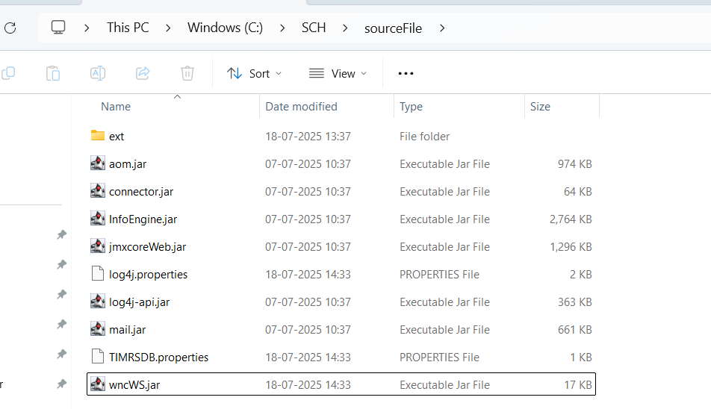

Compile Source Files
- Install amazon-corretto-21.0.7.6.1 on local system (Version should be compatible with Arbortext Editor Version)
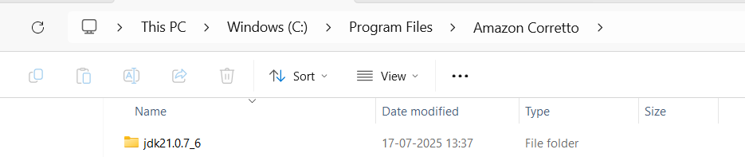
- Open cmd and check installed java version using java - version command.
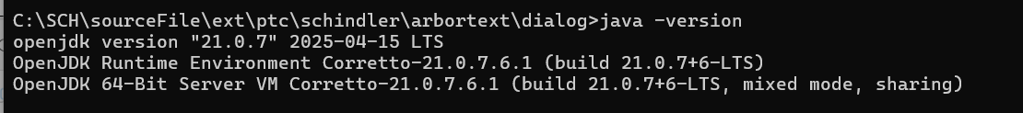
- Create C:\SCH\bin folder
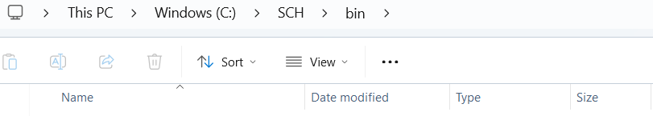
- Run below command to compile all source files
javac -cp "C:\SCH\sourceFile\*" -d C:\SCH\bin C:\SCH\sourceFile\ext\ptc\schindler\arbortext\dialog\*.java C:\SCH\sourceFile\ext\ptc\schindler\arbortext\migration\ie\*.java C:\SCH\sourceFile\ext\ptc\schindler\arbortext\migration\*.java C:\SCH\sourceFile\ext\ptc\schindler\arbortext\utils\*.java
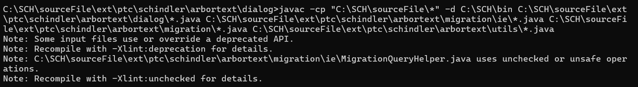
- Validate .class files are generated in C:\SCH\bin folder
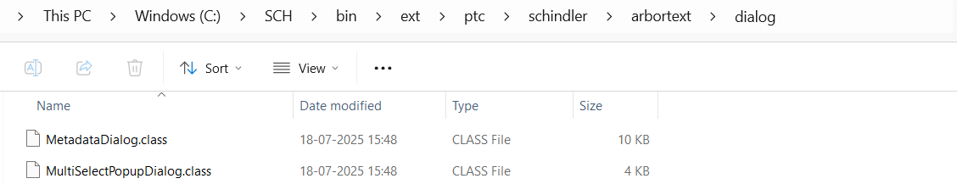
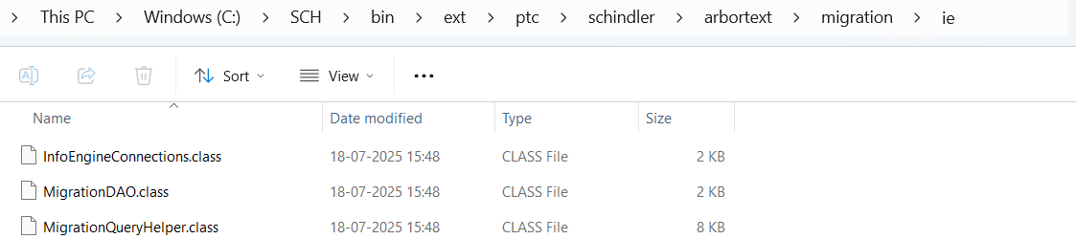
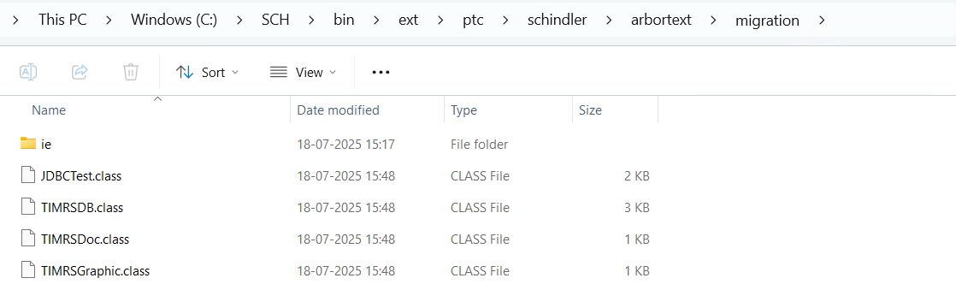
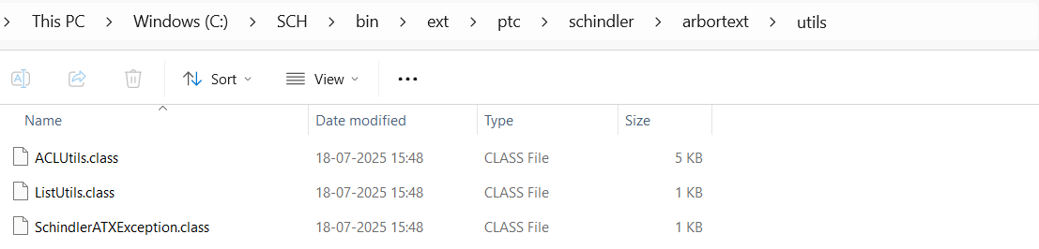

Deployment on APE Server
- Share ext folder with all .class file with APE Worker Team.
- Delete log4j-api.jar jar from C:\SCH\sourceFile as this is already available on APE server, It will give error if we keep this jar in package.
- Deploy below jars on APE server
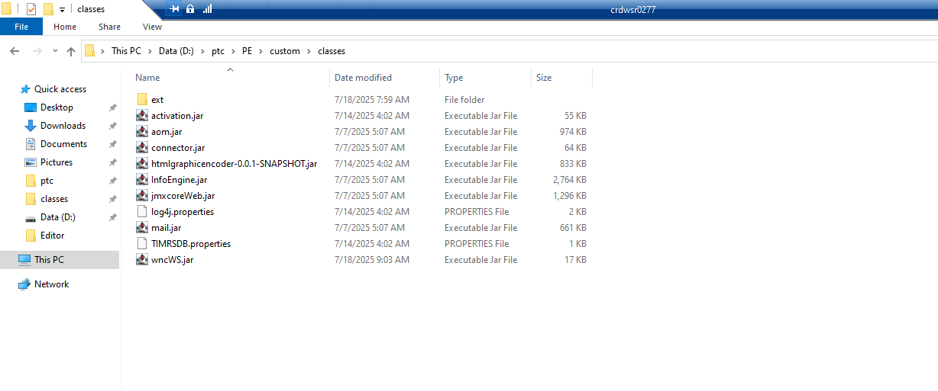
- htmlgraphicencoder-0.0.1-SNAPSHOT.jar is taken from existing APE server.
- Start APE Server and Validate its starting with any compilation or class not found errors.
- If .class files are not compiled as per installed Java version on APE server then we will get below error
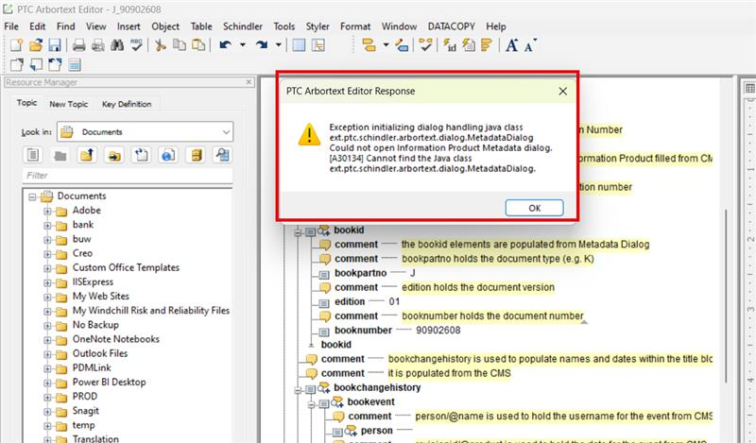

wvs.jar creation and windchill OOTB jars
- Windchill jar need to be placed on APE worker server as Schindler has dedicated server for APE Worker.
- Need below windchill jar on APE server
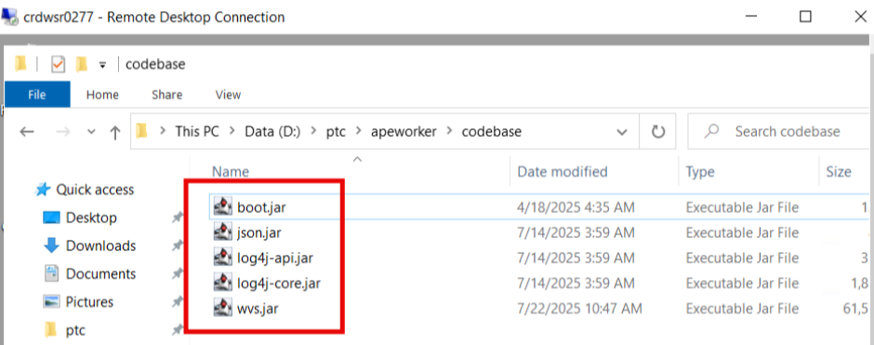
- wvs.jar we need to create it on Application server by follwing below steps
Open a windchill shell
Navigate to <WTHOME>/codebase
- Run the below command in Windchill shell
ant -f wvsMakeJar.xml
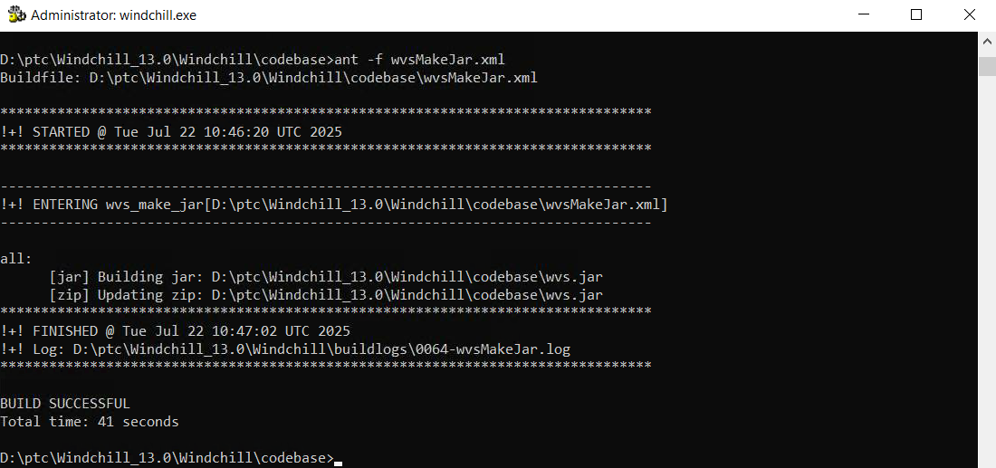
- The jar is created in <WTHOME>/codebase
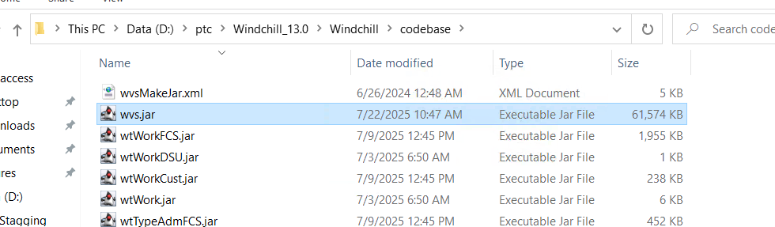
- Copy wvs.jar to local drive
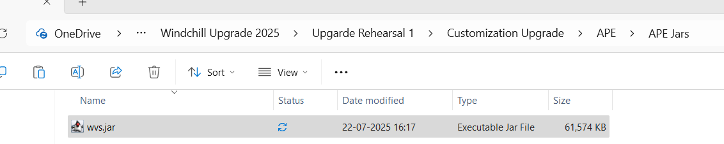
- Copy json.jar from <WC_HOME>\srclib to local drive
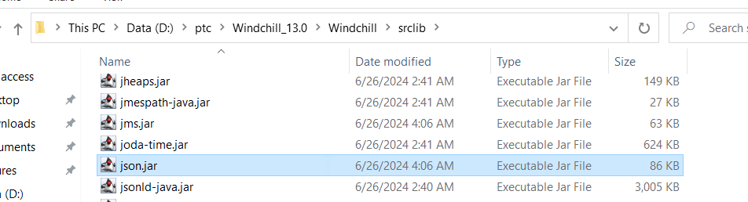
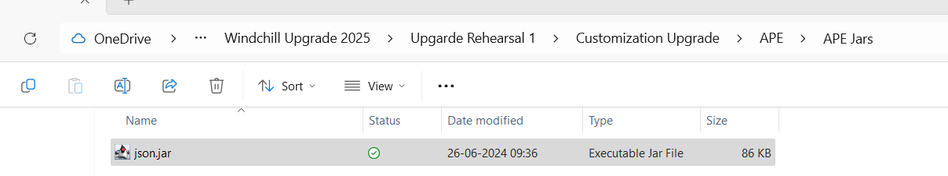
- Copy boot.jar from <WC_HOME>\codebase\install to local drive
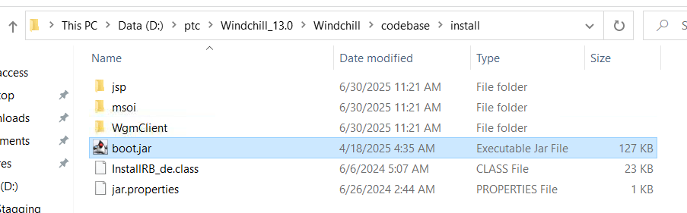
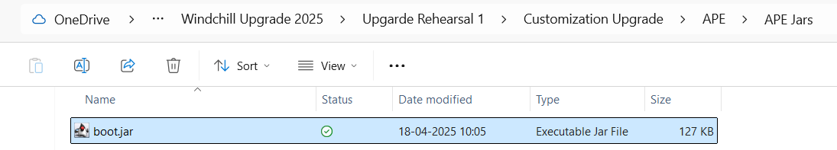
- Copy log4j-api.jar from <WC_HOME>\srclib to local drive
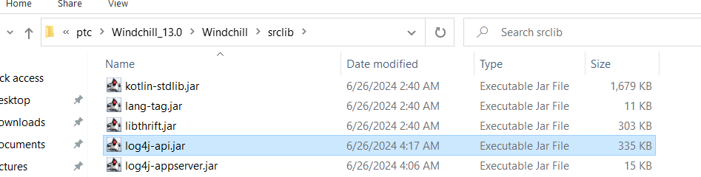
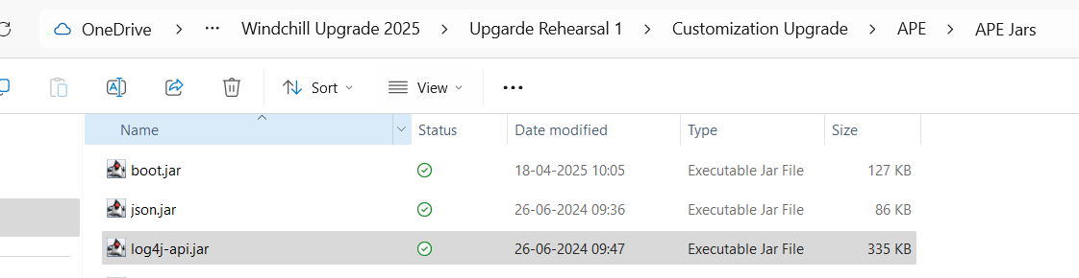

- Copy log4j-core.jar from <WC_HOME>\srclib to local drive
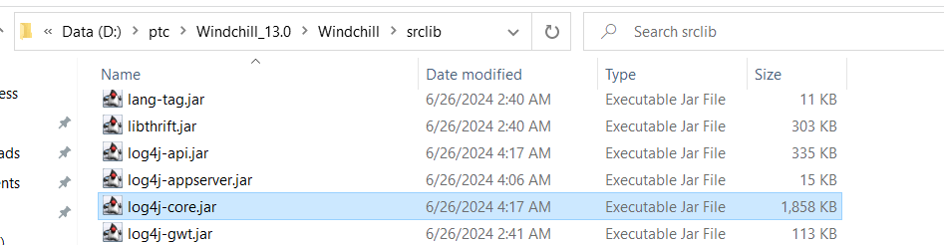
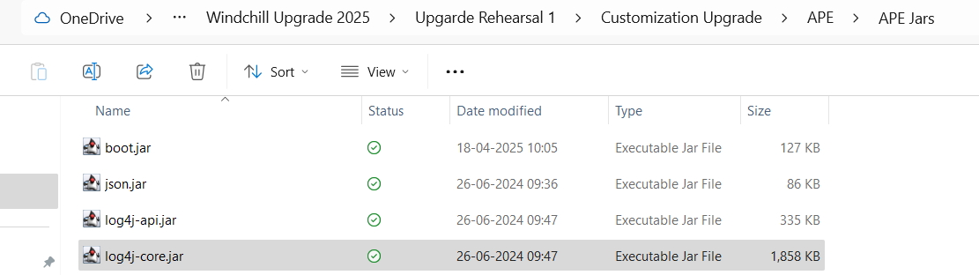
- Share all below mentioned jars to APE team which we copied from windchill server in above steps.
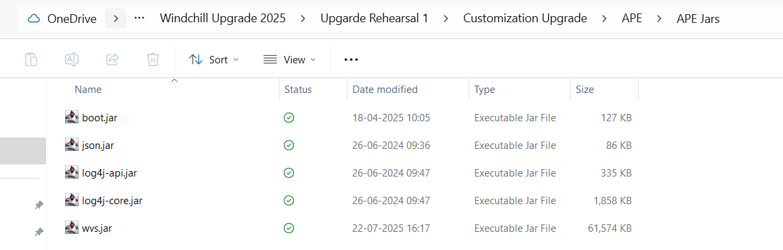

Issues and Resolution

APE worker is not starting form Worker Agent Administration

Issue
- After configuration of APE worker, It was not starting from Worker Agent Administration.
- Worker Agent Administration Window was just spinning after Clicking on Start Worker for APE Worker
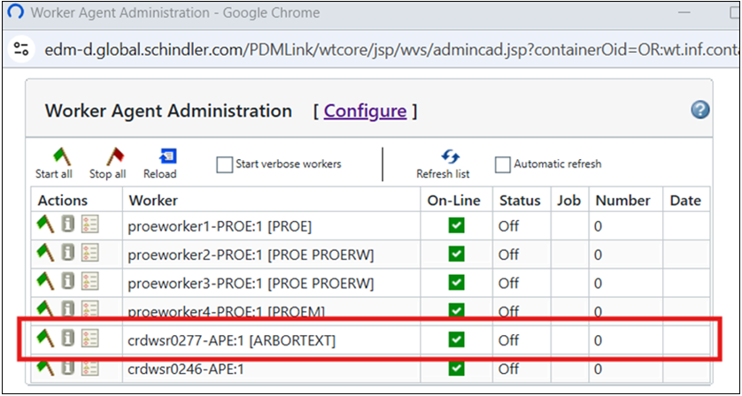

Resolution
- Need to add below lines in D:\ptc\apeworker\arbortextEngineWorkerstart.bat on APE Worker Server (CRDWSR0277)
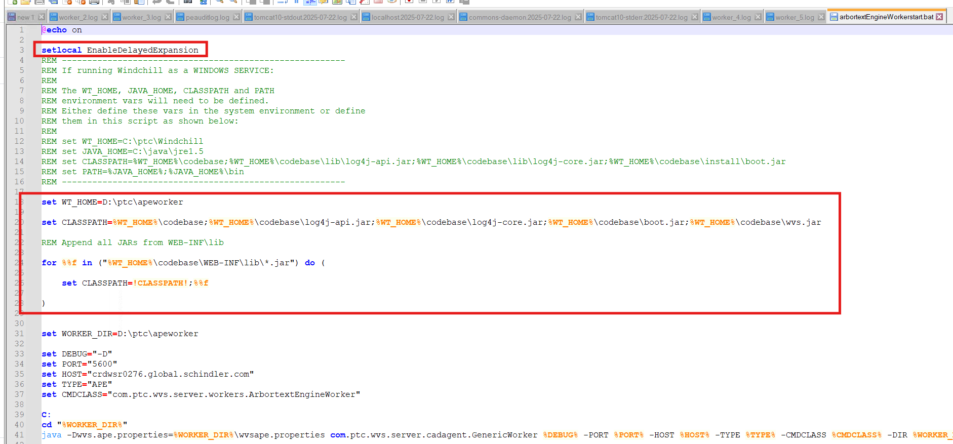
- Add boot.jar to D:\ptc\apeworker\codebase (on CRDWSR0277 ) from <WC_HOME>\codebase\install (From CRDWSR0276)
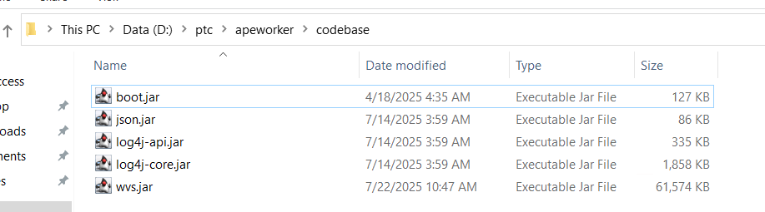
- Updated publish.cadconvert.ARBORTEXT property value in schindler.xconf as per below snapshot
